Iteration 3 Report

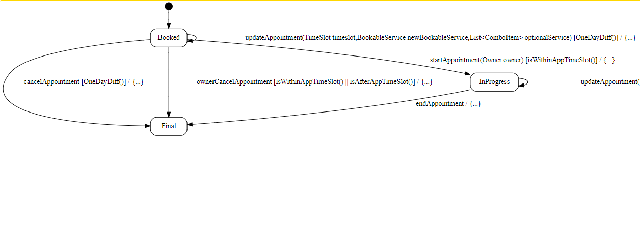

Transition cancelAppointment : if the client wants to cancel his booked appointment, the state machine will check if there is at least one day between the appointment day and the day on which the client wants to do the action.

Transition ownerCancelAppointment: If the owner wants to cancel the appointment because the client didn’t come, the state machine will check if the appointment is supposed to be in progress or if the appointment was in progress before, then will allow or not the action.

Transition updateAppointment: Will check if there is a one-day difference between the system time and the appointment date and will then allow or not the client to make his update.

Transition updateAppointment in inProgress state: checks if the appointment is in progress to decide if the client can modify his appointment during the appointment.

Transition endAppointment: changes the state of the appointment from inProgress to Final.